Operation Sky Haven: Elevating Comfort for Israel's Defenders
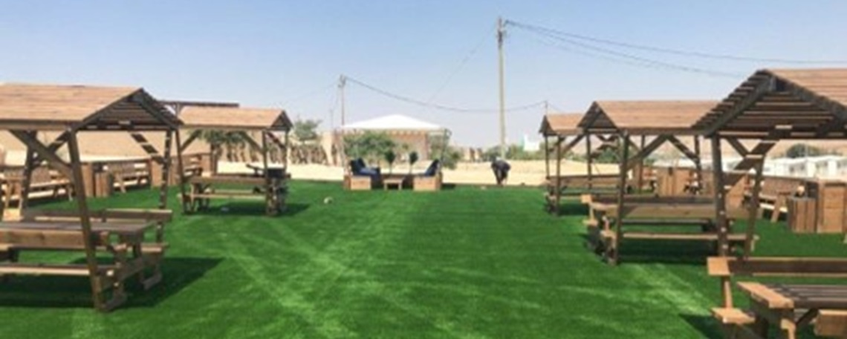
photographer : Illustrative photo- The Association for the Wellbeing of Israel's Soldiers (AWIS)
KKL-JNF is gifting IAF pilots with new rest spots where they can lift their feet and relax after a hard day of flying.
Ramon Airbase is an Israeli Air Force (IAF) base in the Negev desert, south of Beersheba and northwest of the town Mitzpe Ramon. The base is also titled Kanaf 25 (lit. Wing 25).
The AFB is home to three F-16I Sufa squadrons, and two squadrons of AH-64A/D Apache (Longbow) Peten/Saraf attack helicopters, the only ones in Israel.
On April 13th, 2024, the Islamic Revolutionary Guards Corps of Iran fired large numbers of missiles and drones into Israel, apparently targeting the base.
The IAF stands as a critical pillar of defense, ensuring Israel's security with unparalleled precision and strategic prowess. With a rich history of safeguarding the nation from aerial threats, the IAF exemplifies innovation and operational excellence in the face of evolving challenges .
Manned by highly skilled personnel, the IAF maintains air superiority, swiftly responding to threats and safeguarding Israel's borders. As a cornerstone of Israel's defense strategy, the IAF's unwavering dedication ensures that the skies over Israel remain secure, contributing to a safer future for all its citizens.
The Keren Kayemeth LeIsrael - Jewish National Fund (KKL-JNF), together with the Ha'aguda Lema'an Hachayal; the Association for the Wellbeing of Israel's Soldiers (AWIS), is providing the pilots and crewmen with a rest area at the Ramon base.
The rest spot includes 450 square meters of synthetic grass, planters, trash cans, synthetic vegetation, and benches.
The shaded outside recreational area offers soldiers an opportunity to unwind, bond with their comrades, and take a mental break from the stresses of combat.
They put their lives on the line for our safety. We must ensure that they are rested and well prepared for the mission.
Particularly in these times of war and hardship, it is imperative we show our appreciation to the special soldiers of the IDF. As we honor their sacrifice and commitment, we believe that maintaining their mental and physical well-being is paramount.
This project is a testament to KKL-JNF’s unwavering commitment to the well-being of IDF soldiers. The donated recreational areas and every moment of relaxation it brings will contribute to the physical and emotional strength of those who protect our nation.
In these challenging times, the well-being of our soldiers is non-negotiable. The rest areas are gesture of appreciation, support, and unity.
KKL-JNF invites you to join us in creating a more relaxed and resilient IDF, ensuring that our soldiers can face any challenge with renewed vigor.
Project Number: 21485
Keren Kayemeth LeIsrael-Jewish National Fund
Resource Development and External Affairs Division
Marketing Department
Jerusalem 2024

